Experiment 01

**Aim:**

To explore and analyze various development boards and platforms used in building Internet of Things (IoT) applications.

**Objectives**

* To understand the basic architecture and components of IoT systems.
* To compare multiple development boards and platforms available for IoT.
* To select an appropriate development ecosystem for a given IoT application.

**Theory:**

**Introduction to IoT**

The Internet of Things (IoT) is a system of interrelated physical devices equipped with sensors, software, and connectivity, enabling them to collect and exchange data in real time. These devices operate autonomously to enhance decision-making, efficiency, and automation across various domains such as healthcare, agriculture, manufacturing, and smart cities.

**Core Components of an IoT System**

1. **Sensors and Actuators** – Sensors gather data (e.g., temperature, humidity) while actuators respond by taking physical action.
2. **Processing Units / Development Boards** – Boards like Raspberry Pi, Arduino, and ESP32 process sensor data and control devices.
3. **Connectivity Modules** – Enable communication using technologies like Wi-Fi, Zigbee, LoRa, or cellular networks.
4. **Software and Cloud Platforms** – Handle data analytics, storage, visualization, and device management remotely.
5. **Communication Protocols** – Protocols such as MQTT, CoAP, and HTTP ensure reliable and secure data exchange.

**IoT Development Boards:**

**Introduction to IoT**

The Internet of Things (IoT) refers to a vast network of interconnected physical devices that are embedded with sensors, software, and other technologies. These devices collect and exchange data through the internet to enable automation, control, and decision-making. IoT connects the physical world to the digital realm, allowing seamless data flow and remote monitoring across various domains such as smart homes, healthcare, agriculture, transportation, and industrial automation.

An IoT system typically consists of several key components: sensors and actuators to detect and act upon environmental conditions, development boards to process data, communication modules for transmitting data, cloud platforms for storage and analytics, and protocols that manage secure and efficient data exchange.

**Raspberry Pi**

Raspberry Pi is a powerful single-board computer that runs a full Linux operating system. It is widely used in projects that require moderate to high processing power, such as edge computing, artificial intelligence, and multimedia-based IoT systems. It features multiple USB ports, HDMI, Ethernet/Wi-Fi, and a GPIO interface, enabling connectivity with various peripherals. With support for languages like Python and C++, Raspberry Pi is ideal for advanced development, including smart surveillance, automation, and custom IoT solutions.

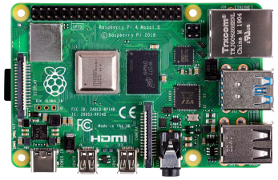

**Intel Edison**

Intel Edison was a compact, high-performance development board designed for IoT and wearable applications. It featured integrated Wi-Fi and Bluetooth, and supported the Yocto Linux OS. Developers could program it using C, C++, Python, and Node.js. Despite its small form factor, it housed a dual-core Atom processor, making it capable of real-time data processing and embedded computing. Although discontinued, Intel Edison was once popular in healthcare, home automation, and industrial projects due to its performance and wireless capabilities.

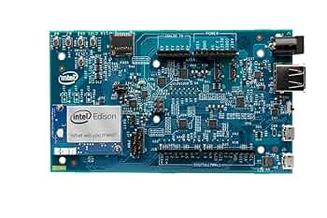

**Arduino Uno**

Arduino Uno is one of the most beginner-friendly and widely adopted microcontroller boards. It is based on the ATmega328P chip and is perfect for basic IoT applications such as sensor interfacing, motor control, and home automation. The board features 14 digital I/O pins, 6 analog inputs, and runs at a clock speed of 16 MHz. With USB support and an easy-to-use Arduino IDE, it enables quick prototyping and experimentation. It is especially favored in educational setups and small-scale embedded applications.

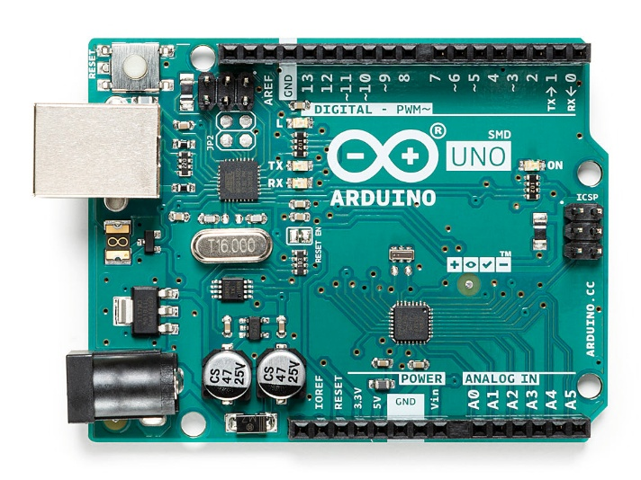

**ESP32**

ESP32 is a low-cost, high-performance system-on-chip (SoC) that includes dual-core processors, built-in Wi-Fi and Bluetooth, multiple GPIO pins, and integrated ADCs and DACs. It supports programming via Arduino IDE, MicroPython, and the native ESP-IDF framework. ESP32 is ideal for battery-operated and real-time IoT applications such as smart lights, wearable devices, and industrial sensors. Its power efficiency, processing capabilities, and wireless integration make it one of the most popular choices in IoT development today.

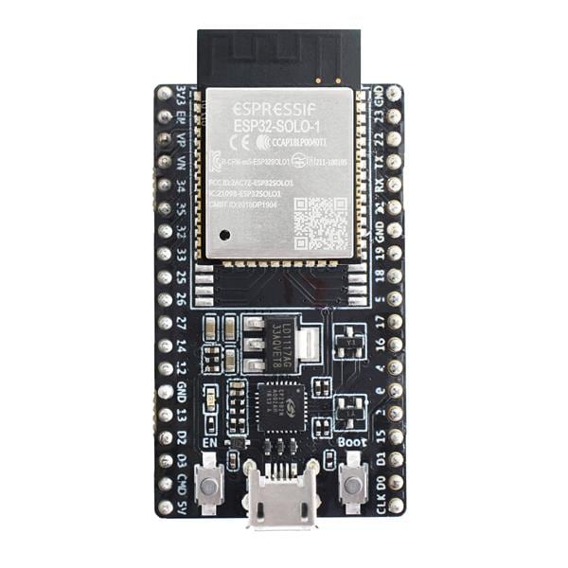

**ESP8266**

ESP8266 is a compact and affordable Wi-Fi-enabled microcontroller that has become a staple for IoT developers working on lightweight, internet-connected projects. It features a single-core processor and basic GPIO support. While not as powerful as ESP32, it performs exceptionally well in tasks like remote sensing, data logging, and cloud interaction. ESP8266 supports protocols like HTTP and MQTT, and can be programmed using the Arduino IDE or Lua scripting. It is commonly used in smart switches, wireless temperature monitors, and DIY IoT projects.

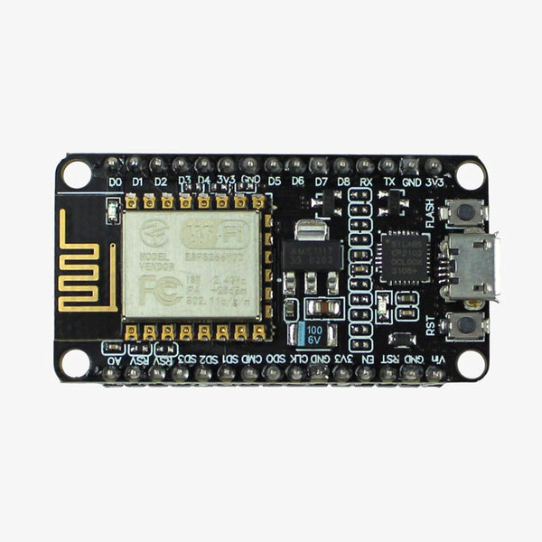

**NodeMCU**

NodeMCU is a development board built around the ESP8266 chip and designed for easy prototyping of IoT applications. It includes onboard Wi-Fi, USB connectivity, and voltage regulation. NodeMCU supports Lua scripting and the Arduino IDE, making it a flexible and developer-friendly option. Its compact size and integrated components make it perfect for building weather monitoring systems, smart home controllers, and wireless automation solutions. It is widely appreciated for its low cost, simplicity, and open-source firmware.



**BeagleBone Black**

BeagleBone Black is an embedded Linux computer that is well-suited for complex IoT applications. Powered by an ARM Cortex-A8 processor, it supports full Linux distributions like Debian. It includes Ethernet, HDMI, USB, and 65 GPIO pins, making it highly extensible for hardware interfacing. BeagleBone Black is preferred in industrial automation, robotics, and systems requiring real-time data acquisition. Its high-speed processing and multiple I/O options make it ideal for engineers working on sophisticated embedded solutions.

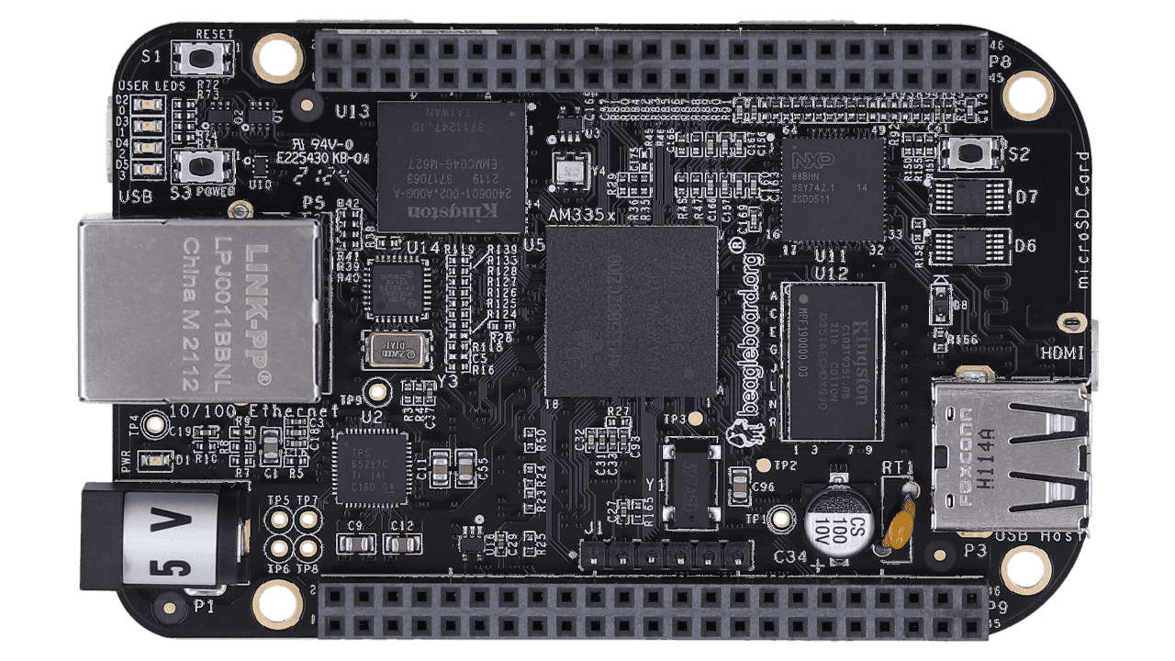

**Arduino YUN**

Arduino YUN combines the simplicity of the Arduino platform with the power of a Linux-based system. It includes the ATmega32U4 microcontroller and an Atheros AR9331 processor running OpenWrt. With built-in Wi-Fi support, Arduino YUN is suitable for projects that require both low-level hardware control and network communication. It is used in applications like IoT gateways, remote monitoring systems, and smart appliances. The board offers flexibility by enabling developers to perform complex network tasks while handling real-time sensor inputs.

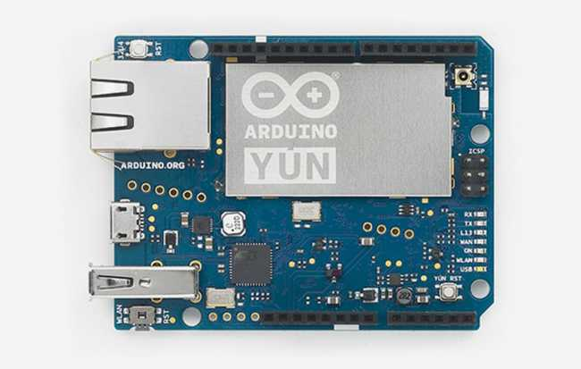

**IoT Cloud Platforms**

**AWS IoT**

AWS IoT is a cloud service offered by Amazon Web Services that enables secure and scalable device connectivity. It provides features such as device provisioning, secure communication, real-time analytics, and seamless integration with AWS Lambda and other services. AWS IoT supports large-scale industrial applications, remote monitoring, and real-time control, making it suitable for enterprise-level IoT systems.

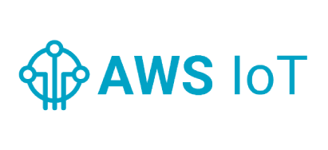

**Google Cloud IoT**

Google Cloud IoT is a fully managed service for securely connecting and managing IoT devices. It integrates well with Google’s data analytics and machine learning tools like BigQuery and Vertex AI. The platform supports real-time monitoring, data ingestion, and secure device provisioning, making it ideal for smart agriculture, urban infrastructure, and connected manufacturing systems.

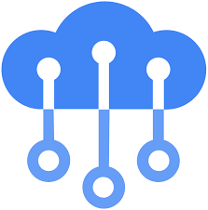

**Microsoft Azure IoT Suite**

Azure IoT Suite provides a wide range of cloud services for connecting, monitoring, and controlling IoT devices. It includes features like device twins, real-time telemetry, and integration with visualization tools such as Power BI. It supports edge computing, enabling processing closer to the source. Azure IoT is commonly used in smart energy systems, supply chain logistics, and industrial monitoring.

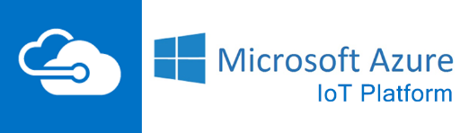

**IBM Watson IoT**

IBM Watson IoT is an AI-powered IoT platform that offers advanced analytics, real-time monitoring, and cognitive computing capabilities. It enables natural language processing, machine learning, and predictive maintenance. The platform is used in smart buildings, healthcare monitoring systems, and industrial automation to enhance decision-making and reduce operational costs.

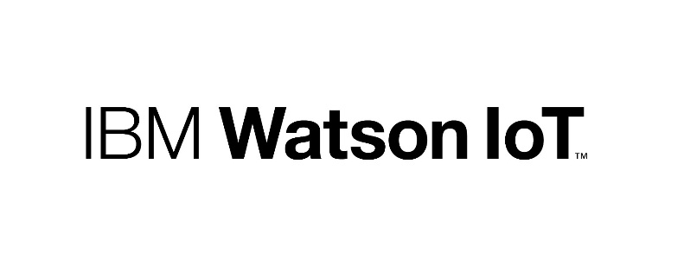

**ThingSpeak**

ThingSpeak is an open-source IoT analytics platform used primarily in academic, research, and hobbyist projects. It enables data collection, storage, analysis, and visualization. It integrates with MATLAB for performing advanced analytics. Its simplicity, ease of setup, and no-cost access make it an excellent choice for students and educators working on smaller IoT deployments.



**Observations and Results**

* Raspberry Pi and BeagleBone Black are best suited for applications requiring real-time processing and complex tasks like AI and edge computing.
* ESP32, NodeMCU, and ESP8266 are affordable and efficient choices for wireless sensor networks and automation.
* Arduino Uno is best for educational, beginner-level, and simple sensor-based projects.
* AWS IoT and Google Cloud IoT offer robust solutions for large-scale, secure, and commercial-grade IoT deployments.
* ThingSpeak is suitable for academic, research, and prototype applications due to its simplicity and accessibility.

**Conclusion:**

Understanding the variety of available IoT development boards and platforms is essential for building functional and scalable systems. The selection of components should depend on the project’s specific needs, such as computing power, wireless communication, energy consumption, and ease of integration. Lightweight applications benefit from low-cost solutions like ESP32 combined with ThingSpeak, while industrial applications may require more advanced setups like Raspberry Pi with AWS or Google Cloud for edge processing and cloud synchronization.